**Experiência 1**

1. Conectar o E0 do Tux13 e do Tux14 numa das entradas do switch
2. Configurar os IPs de cada computador

$ ifconfig eth0 up

$ ifconfig eth0 <IP>

- 172.16.10.1/24 para o Tux13

- 172.16.10.254/24 para o Tux14

1. Para ver o MAC address de cada computador, consultar o campo ether no comando ipconfig;
2. Verificar a conexão dos dois computadores na mesma rede. Em cada um tenta enviar pacotes de dados para outro. A conexão está correcta quando todos os pacotes são recebidos:

$ ping <IP>

- 172.16.50.254 para o Tux13

- 172.16.50.1 para o Tux14

1. Avaliar a tabela Address Resolution Protocol (ARP) do Tux13 onde esta deverá ter apenas uma entrada com o IP e o MAC do Tux14. Para visualizar a tabela:

$ arp -a

# ?(172.16.50.254) at 00:c0:df:25:13:65 [ether] on eth0

1. Apagar a entrada da tabela ARP do Tux13:

$ arp -d 172.16.50.254

$ arp -a

# empty

1. Abrir o WireShark no Tux13 e começar a capturar pacotes de rede;
2. Executar o seguinte comando no Tux13:

$ ping 172.16.10.254 -c 10

1. Parar a captura dos resultados e avaliar os logs obtidos com o WireShark.

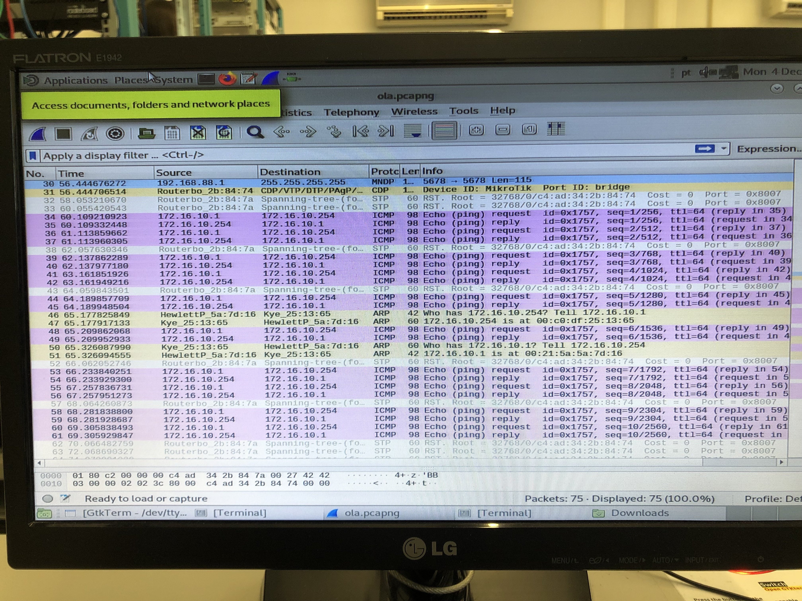

**Questões**

* What are the commands required to configure this experience?

To configure this experience, we only have to use these commands:

$ ifconfig eth0 up

$ ifconfig eth0 <IP>

- 172.16.10.1/24 para o Tux13

- 172.16.10.254/24 para o Tux14

* What are the ARP packets and what are they used for?

The ARP packets (Address Resolution Protocol) are the ones that its main purpose is to establish a connection between an IP and a MAC address.

* What are the MAC and IP addresses of ARP packets and why?

It is sent 2 IP addresses in broadcast in the same ARP packet, one corresponds to the destination machine (172.16.10.254, Tux14) and the other one corresponds to the origin machine (172.16.10.1, Tux13). As a response, the Tux14 sends an ARP packet to the Tux13 that its MAC address (00:c0:df:25:13:65).

* What packets does the ping command generate?

While it doesn’t receive the MAC address of the destination machine, the *ping* generates ARP packets. After making the connection between the IP address and the corresponding MAC address, it generates an ICMP packet (Internet Control Message Protocol) to transfer the information.

* What are the MAC and IP addresses of the ping packets?

The addresses used in ICMP packets are the IP and MAC addresses from the machines Tux13 and Tux14.

* How to determine if a receiving Ethernet frame is ARP, IP, ICMP?

The designation of the protocol of each frame is present at the “Protocol” column as you can see from the photo of the Wireshark. Usually, the protocol is indicated by the first 2 bytes of the frame.

* How to determine the length of a receiving frame?

There is a column in Wireshark that shows the size of the frames (bytes). Usually, the header of each frame contains that information as well.

* What is the loopback interface and why is it important?

It is a virtual interface that is always reachable as long as one of the IP interfaces from the switch is operational. So, it is possible to verify periodically if the network connections are well configured.

**Experiência 2**

1. Conectar o E0 do Tux62 e configurar o IP:

$ ifconfig eth1 <IP>

- 172.16.61.1/24 para o Tux62

1. Criar 2 “bridges” no switche: bridgeY0 e bridgeY1
2. Remover as portas onde estão conectadas os tux63, tux64 e tux62 das “default bridges”
3. Abrir o wireshark no tux63.eth0
4. No tux63 vamos dar ping o tux64 e depois vamos dar ping no tux62.
5. Após darmos as pings, paramos a captura e salvamos o log
6. Depois vamos começar novamente novas capturas nos tux62, tux63 e tux64
7. Depois no tux63 vamos dar ping ao “Broadcast” durante alguns segundos.
8. Depois repetimos o processo (passos 7 e 8) mas demos ping no Broadcast no tux62

**Experiência 3**

1. Conectar o E1 do Tux64 e configurar o IP:

$ ifconfig eth1 <IP>

- 172.16.61.253/24 para o Tux64

1. Remover a porta, onde está conectada o tux64, a “default bridge” e de seguida, adicioná-la à bridge61.
2. Enable IP forwarding e disable ICMP echo-ignore-broadcast
3. Observamos que os endereços IP e MAC do tux64.eth0 e do tux64.eth1 são:

- eth0: IP->172.16.60.254 MAC->00:21:5a:c5:61:bb

- eth1: IP->172.16.61.253 MAC->00:01:02:a1:35:69

1. Adicionar routes Tux62 e tux63
2. Iniciar a captura no tux63 e dar ping às outras tux
3. Parar a captura e guardar os logs
4. Após isto, abrir o wireshark no eth0 e no eth1 no tux64
5. Dar clear às tabelas ARP nos 3 tuxes
6. No tux 63, dar ping ao tux 62 durante alguns segundos
7. Parar a captura e guardar os logs

**Experiência 4**

1. Limpar o gkterm
2. Ligar ether1 do Rc ao 6.1 e o ether2 do Rc à porta da bridge61:

- /interface bridge port remove [find interface=ether19]

- /interface bridge port add bridge=bridge61 interface=ether19

1. Ligar o cabo que estava ligado ao switch ao router MT
2. Configurar os endereços IP do Rc através da consola serial do router
3. Adicionar como default router o tux 64 do tux63
4. Adicionar como default aos tuxes 62 e 64, o Rc
5. No tux62 e no Rc adicionar routes para o 172.16.60.0